A Guide to ISO 5840 Testing
- Overview

ISO 5840 – “Cardiovascular Implants & Cardiac Valve Prostheses” is the international standard for bioprosthetic heart valve testing. A common question asked of Vivitro Labs Inc., is “What to do I need to test my valve to the standard?” This white paper is intended to provide guidance to cardiovascular device clients outlining the recommended products and lab testing services we would propose for each phase of your product development.

- Recommended Testing Guide Summary

The following table provides a summary of the testing approach ViVitro Labs would recommend. Each phase of testing is described in more detail in subsequent sections.

Phase | Hydro Dynamic Performance | Durability | Flow Visualization
Research | Buy a ViVitro Pulse Duplicator for hydrodynamic testing.  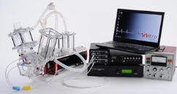 | Buy a ViVitro HiCycle for durability testing.  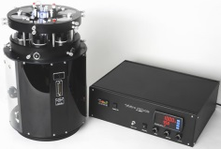 | May not be Applicable.
Development | Engage ViVitro Laboratory Services to conduct Hydrodynamic Testing to validate your internal testing results.  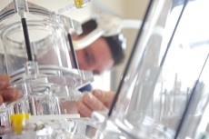 | Engage ViVitro Laboratory Services to conduct Durability Testing to validate your internal testing results.  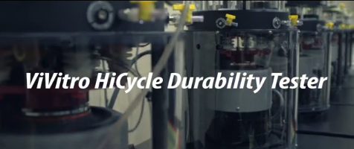 | Engage ViVitro Laboratory Services for Flow Visualization to assess hemolytic and thrombogenic potential or to validate computer simulations.  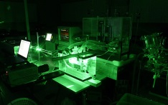
Approval | Engage ViVitro Laboratory Services to perform independent 3rd party Hydrodynamic testing for approval body submission. | Engage ViVitro Laboratory Services to perform independent 3rd party Durability Testing for approval body submission. | Engage ViVitro Laboratory Services to perform independent 3rd party flow visualization for approval body submission.
- ISO 5840 – Mandatory In Vitro Testing

Within ISO 5840 there are currently two annexes for complete device testing: (Annex N and O in ISO 5840:2013 or Annex L and M in ISO 5840:2005), along with several component specific annexes not covered in this white paper.

ISO 5840 | Annex Description
Hydro Dynamic Testing  -  ISO 5840:2005 Annex L  and  ISO 5840:2013 Annex N | Provides guidelines for verification of hydrodynamic performance –  - Hydrodynamic testing shall be performed to provide information on the fluid mechanical performance of the heart valve substitute and provide indicators of valve performance in terms of load to the heart and potential for blood stasis and damage.  - Includes  - Pulsatile-flow testing,  - steady forward testing,  - steady leakage flow testing, and  - Assessment of flow fields including haemolytic and thrombogenic potential of the valve design.  - Pulsatile flow can be conducted using the ViVitro Labs Pulse Duplicator  - Steady flow testing is only available through ViVitro Laboratory services.  - Assessment of flow fields is only available through ViVitro Laboratory services.
Durability Testing  -  ISO 5840:2005 Annex M &  ISO 5840:2013 Annex O | Durability testing –  - An assessment of the durability of the valve shall be performed in order to assess contend function over a reasonable lifetime.  - This is typically done at an accelerated rate however testing at real-time rates is also acceptable.

- Phases of Testing toward ISO 5840 Compliance

For purposes of this white paper the process of taking a heart valve from idea to commercially approved reality is simplified to four phases:
- Research
- Development
- Approval
- Production
From ViVitro’s perspective, these different phases represent different testing needs. To provide guidance on the products and services that ViVitro has to offer, each phase is described below in more detail.
4.1 Research Phase

During the research phase, critical functional performance such as Effective Orifice Area (EOA), regurgitant fraction, paravalvular leakage, and material durability need to be assessed to ensure they meet the design intent and minimum performance requirements outlined in IS 5840. ViVitro Labs recommends hydrodynamic and durability testing to determine the effectiveness of the design.
- Hydrodynamic testing – For the extensive amount of upfront research and simulation of the heart valve, ViVitro recommends purchasing a ViVitro Labs Pulse Duplicator. This will enable the research team to:

- Be capable of simulating variable waveforms and beat rates
- Facilitate mechanical and hemodynamic performance
- Perform Ultrasound assessments
- Have flexibility and real time access to test results
- Durability testing – During the research stage, initial test data indicating the reliability / durability of the valve is essential and buying a HiCycle durability tester will enable the team to test the valve for early life failures as well as beyond the standard’s requirement of 250 million cycles. This will occur in many smaller tests as the get a handle on their failure mechanisms.
- Flow visualization – May not be needed during this phase.

4.2 Development

During the development phase, the company is validating and optimizing the heart valve design for different sizes, reliability and manufacturability. At this phase independent validation of the design, confirmation of the durability and extensive testing under in vitro conditions to ensure success at later stages are key. ViVitro would recommend the following approach:

- Hydrodynamic testing – Engage ViVitro Laboratory Services to perform independent 3rd party Hydrodynamic testing validating the tests performed thus far by the research team.
- Durability testing – Engage ViVitro Laboratory Services to perform independent 3rd party Durability testing validating the reliability / durability of the valve. ViVitro can also do this in parallel with your development team to shorten the testing time and thus speed time to market.
- Flow visualization – Engage ViVitro Laboratory Services to diagnose the flow characteristics to represent disease conditions such as shear stresses and turbulent shear. This allows for a quantitatively assessment of the hemolytic and thrombogenic potential of the valve in each intended position.
4.3 Approval

In the approval phase (for submission to a regulatory body such as CE, FDA, etc.), the client is seeking validation of its design and product to proceed forward from in vitro testing towards animal and first in man trials. As such ViVitro Labs can play an invaluable role as a respected, known and independent 3rd party test lab providing test results to the approval bodies. For this vital stage we would recommend the following approach:

- Hydrodynamic testing – Engage ViVitro Laboratory Services to perform independent 3rd party Hydrodynamic testing validating the tests performed thus far by the research team.
- Durability testing – Engage ViVitro Laboratory Services to perform independent 3rd party Durability testing validating the reliability / durability of the valve.
- Flow visualization – Engage ViVitro Laboratory Services to perform independent 3rd party flow visualization validating the valve design for hemodynamic performance assessment.
- ViVitro Labs Inc.

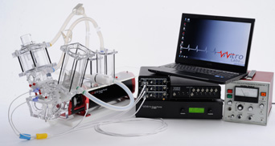
ViVitro Labs Inc. offers industry-leading cardiovascular test equipment and related laboratory testing services. Hundreds of organizations in over 39 countries for 30+ years have trusted ViVitro’s expertise, accuracy, and quality for their heart valve, LVAD, TAH, stent, and synthetic graft testing. As the developer of the world’s first commercial pulse duplicator, the ViVitro name is synonymous with cardiovascular device testing equipment. ViVitro products are designed and manufactured in an ISO 13485, certified facility (StarFish Medical). Our products are widely known by regulatory agencies enabling clients throughout the world to use ViVitro Labs products for regulatory submissions with a track record of success.

  - Pulse Duplicator

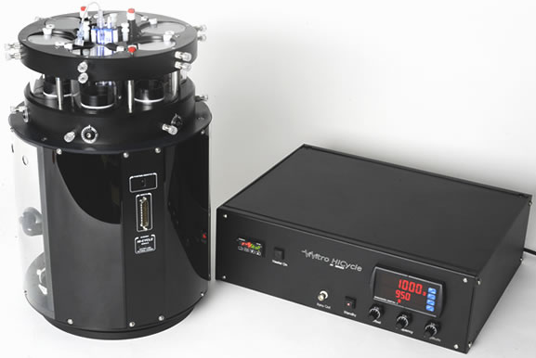
The ViVitro Pulse Duplicator is the world’s most widely used in vitro cardiovascular hydrodynamic testing system to assess the performance of prosthetic heart valves under simulated cardiac conditions. Transparent viewpoints allow distal and proximal viewing of the valve and the ability to conduct ultrasonic echo assessments. The ViViTest data acquisition system allows for various ventricular waveform states and beat rates (2-220 BPM), while capturing physiologically pressures and valve flows. To learn more please visit our website http://vivitrolabs.com/product/pulse-duplicator/

  - HiCycle Durability Tester

The Hi-Cycle Durability Tester is an accelerated wear tester (500 – 1,800 BPM) used to determine the durability of replacement heart valves and other cardiac devices under physiological loading. Clear viewports allow imaging of the valves and pressure ports allow monitoring of the dynamic pressures up and downstream of the valves. The HiTest Data Acquisition System monitors pressure and collects data according to ISO-5840 standards. The results highlight the percent of cycles and percent time per cycle the device is meeting or exceeding target pressure. To learn more please visit our website - http://vivitrolabs.com/product/hicycle-durability-tester/

  - ViVitro Laboratory Testing Services

ViVitro’s Laboratory Testing Services offers an ISO/IEC 17025 certified lab using ViVitro equipment, to conduct 3rd party independent testing. Our accredited testing lab is governed by a mature Quality Management System (QMS) certified to ISO/IEC 17025, (for the scope of accreditation please see http://ViVitrolabs.com/wp-content/uploads/2013/11/A2LA-Certificate-3224-01-2.pdf) to meet the ISO 5840 standard and FDA guidelines for CE, 510K, IDE or PMA supplements.

ViVitro lab personnel are well versed in verification of hydrodynamic performance and assessment of durability testing services for heart valves, transcatheter heart valves, and other cardiovascular devices, leveraging decades of apparatus justification by, and familiarity of, regulatory agencies.
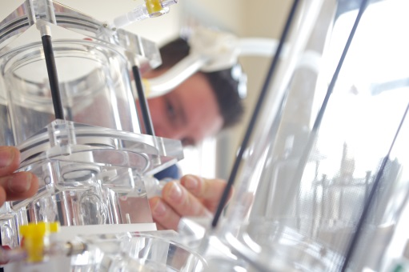
  - Hydrodynamic Testing

ViVitro offers 3 types of Hydrodynamic testing:

- Pulsatile Flow - Hydrodynamic performance assessment is conducted at 70 BPM, 100 mmHg Mean Aortic Pressure and target cardiac outputs of 2, 3.5, 5 and 7 LPM. Regurgitant performance is assessed at a cardiac output of 5LPM with a Mean Back Pressure of 80, 120 and 160 mmHg at 45, 70, and 120 BPM. Valves can be tested in Mitral or Aortic locations. High speed videos of valves in nominal conditions of 5LPM and 100 mmHg Mean Aortic Pressure are included.
- Steady back-flow leakage testing - is measured at constant backpressures ranging from 40 - 200 mmHg.
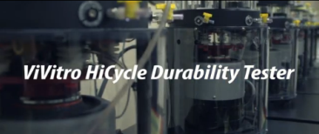
- Steady forward flow testing - is an optional study and may be helpful in verifying the accuracy of the pulsatile flow test. Valves can be tested in a number of standard configurations including, nominal, under-deployed, circular, or elliptical. Valves can be inserted into holders with or without sealing to access paravalvular leakage. The pressure drop across a test valve is measured at flows rates ranging from 5 LPM to 30 LPM.
6.5 Durability Testing

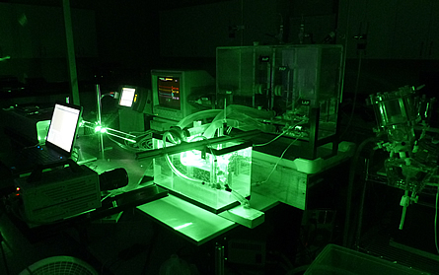
ViVitro offers durability testing using the ViVitro HiCycle Durability tester under appropriate loads while simulating device function to a specified number of cycles (200M minimum) to demonstrate in vitro device durability. Our testing includes a daily visual inspection, a tune check every 10M cycles and hydrodynamic assessment will be conducted pre, post and every 50M cycles during the durability testing. High speed video is also provided.

6.6 Flow Visualization

ViVitro Labs offers the most advanced flow diagnostics capability with our in-house digital particle image velocimetry (PIV) system. By incorporating PIV we can diagnose pulsatile flows and quantify with a high degree of accuracy fluid dynamics such as shear stresses and turbulent shear stresses. This allows for a quantitative assessment of the hemolytic and thrombogenic potential of the valve design in each position of intended use.

- Contact Us

To discuss how ViVitro can best assist you in your testing or for further details please contact us at the above address.

Gerry Wight, B.Eng Rob Fraser, MSc
General Manager Biomedical Engineer – Lab Coordinator

